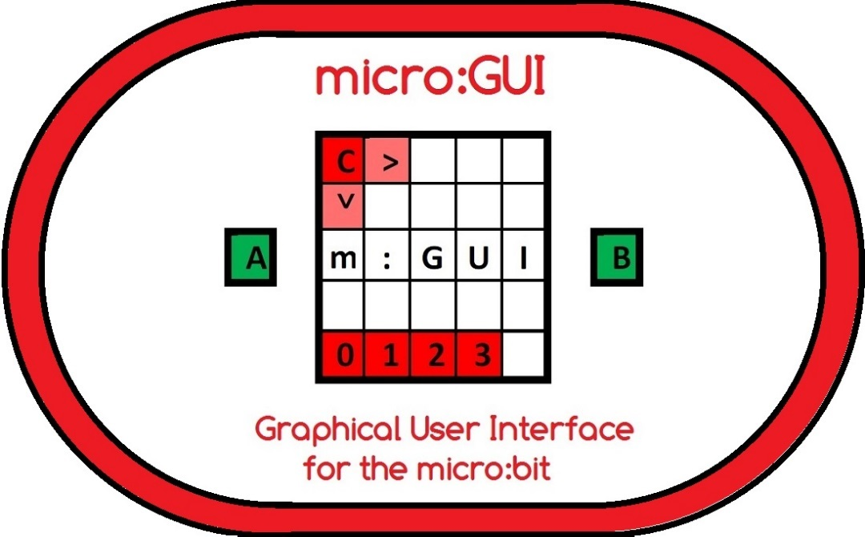
Worksheet 1 - Basic micro:GUI coded in 'Block'
by Innovations in Education
3rd February 2018

micro:GUI Worksheet Overview
The aim of this Worksheet is to help you understand the micro:GUI specification and learn how the micro:GUI works. You are then challenged to write the code for your own 'Basic' micro:GUI in 'Block'.
By following this Worksheet you (or your students) will start to understand the concepts of a Graphical User Interface (GUI). You will see how a GUI makes it easier for users to interact with a computer and appreciate what features make a GUI intuitive to use.
The Worksheet assumes that you (or your students) are already familiar with programming the micro:bit in 'Block'

What you will need:-
- A PC, Mac or Tablet set up to program in 'Block' using the 'MakeCode' (previously known as PXT) Editor (https://makecode.microbit.org/)
- A micro:bit with USB cable
- A speaker attached to micro:bit GPIO P0 (Optional)
- A PDF copy of the micro:GUI specification downloaded from
http://www.zbit-connect.co.uk/microGUI/
- A copy of the example program 'microbit-microGUI-Block-Example.hex' downloaded from http://www.zbit-connect.co.uk/microGUI/

Introduction Step 1:- The best way to understand the micro:GUI specification is to start by loading the 'microGUI-Block-Example.hex' file onto your micro:bit and try it out!
When the program starts the Cursor LED [C] should flash in the top left corner of the micro:bit's display and 3 micro:App LEDs should be illuminated in the bottom left.
Use micro:bit Buttons <A> or <B> to move the Cursor. See how you can move the Cursor to anywhere on the display using a maximum of 8 Button presses.
Move the Cursor onto one of the micro:App LED's and see how the App's 'micro:Icon' is displayed.
When the Cursor is on a micro:App LED, press Buttons <A+B> together to 'launch' the micro:App. Each micro:App in the 'micro:GUI-PXT-example.hex' file plays a different tune and scrolls the micro:App number across the screen.
To return to the 'Home Screen' at any time, press the <Reset> Button

Introduction Step 2:- Now read the micro:GUI specification.
Now that you've tried using the micro:GUI, the specification should make more sense!
Note that when coding in Block, JavaScript or Python the LED's on the micro:Bit's display are numbered using (x, y) co-ordinates as shown with:-
- (0, 0) the top left LED
- (4, 0) the top right LED
- (0, 4) the bottom left LED
- (4, 4) the bottom right LED,
 | x | 0 | 1 | 2 | 3 | 4 | y
 |  |  |  |  |  |  | 0
 |  |  |  |  |  |  | 1
A |  |  |  |  |  |  | 2 | B
 |  |  |  |  |  |  | 3
 |  |  |  |  |  |  | 4

Coding Step 1:- Write the code to control the Cursor
Try and write the code yourself but if you get stuck there is some 'Step 1' example code at the end of the Worksheet.
The code needs to:-
- Define a pair of variable for the x and y the co-ordinates of the Cursor and initialise them to (0,0)
- Define a function that updates the Display by using 'clear screen' then 'Plot x y' to illuminate the Cursor LED
- Call this function in a 'forever' loop
- Add one to the variable for the x co-ordinate on Button <A> Press
- Add one to the variable for the y co-ordinate on Button <B> Press
- When the x co-ordinate reaches 5 the Cursor will go off the right edge of the screen so set it back to 0 so it reappears on the left
- Similarly when the y co-ordinate reaches 5 the Cursor will go off the bottom edge of the screen so set it back to 0 so it reappears at the top
Do you think it is more intuitive to have the <A> or <B> Button moving the cursor 'Right'? If you think it is more intuitive to use the <B> Button to move the cursor 'Right' then change it!
- If you have a speaker attached to your micro:bit, add 'play tone' whenever the Cursor moves, using a different tone when it moves x and y direction

Coding Step 2:- Write the code to display the micro:App LED's
You will need to:-
- Modify the Display function by using 'Plot x y' to illuminate each of the micro:App LED's along the bottom of the display.

Coding Step 3:- Write the code to display the micro:Icons
You will need to:-
- When the Button <A> or <B> is presses and the Cursor co-ordinates are changed, add a check to see if the new co-ordinates are on a micro:App LED. If so set a variable called 'icon_on' to 'true'. If not set this variable to 'false'. (This variable is known as a 'Flag')
- In the 'forever' loop, if the 'icon_on' flag is set, call a new function called 'icon' to display the icon, otherwise call the function to display the normal micro:GUI screen
- Add the new 'icon' function using 'if, else if' statements to check which micro:App LED's the Cursor is on and if display a suitable icon (Block provides a number of icons in the 'Basic' menu.

Coding Step 4:- Write the code to launch the micro:Apps
You will need to:-
- Add code for when Buttons <A+B> are pressed. This code should check the co-ordinates of the Cursor and call the associated micro:App function. e.g. function 'App0' for micro:App 0, function 'App1' for micro:App 1, etc

Coding Step 5:- Write the code for the micro:Apps
Finally you will need to:-
- Write the code for each of your micro:Apps in functions 'App0', 'App1', etc!
(A simple micro:App might be to play a tune (melody) from the 'music' menu and scroll a message across the display while the tune plays)

You now have a working micro:GUI !
...but can you make it even better?

Example Code for Step 1 - Controlling the Cursor
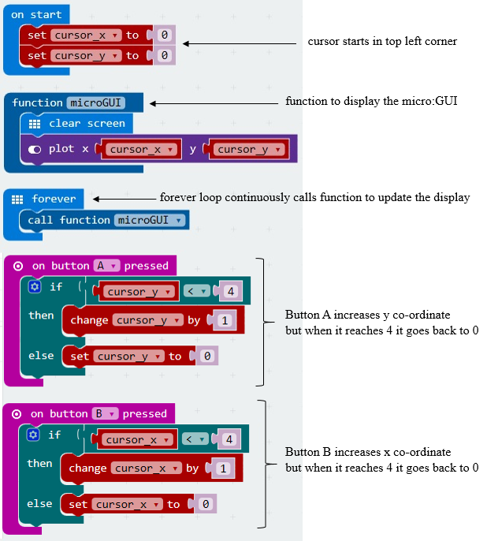

Example Code for Step 5 - Fully working basic micro:GUI in 'Block'
The code for 'microbit-microGUI-Block-Example' can be found on:-
http://www.zbit-connect.co.uk/microGUI/
Note that the example code includes code to 'blink' the Cursor which make the Cursor stand out.
How could you modify your code to make the Cursor blink?

